**1.1 I can describe what web site content and layout will be needed for each Page**

Wireframe is a visual representation of what a single web page will look like, which includes its structure and functionality. These diagrams are used in early stages of the development process.

Below are the wire diagrams for my first web site:

**Home Page**

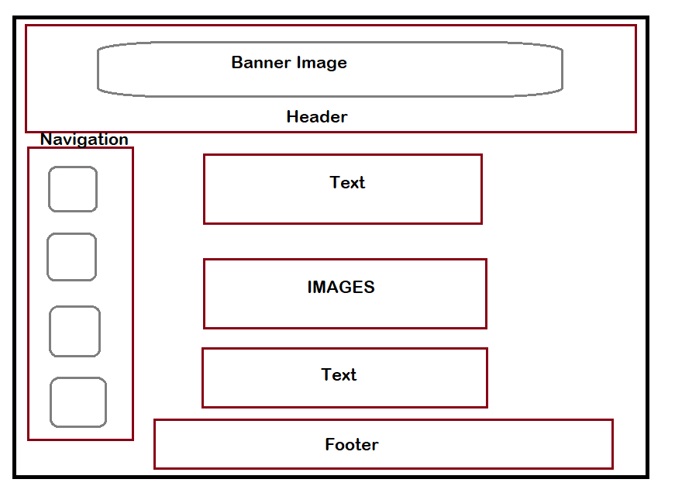

**Page 1**

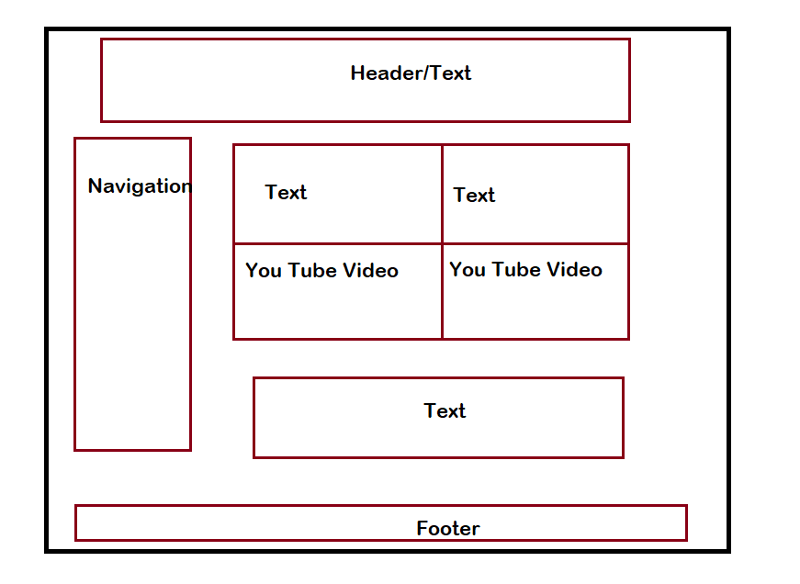

**Page 2**

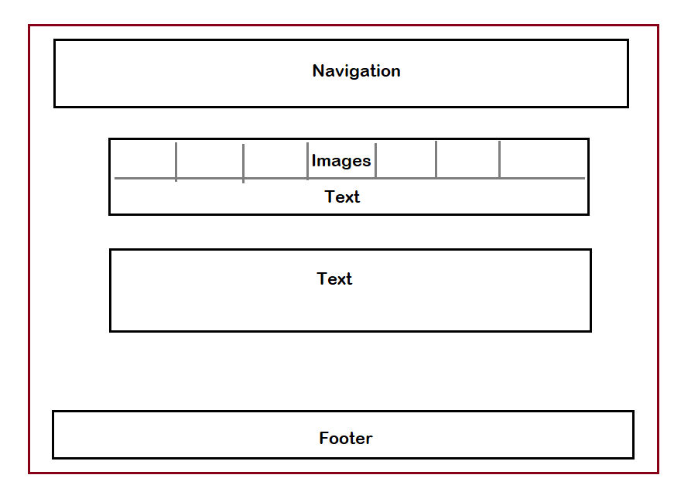

**Contact Page**

